CHAPTER 5
TASK SUMMARIES FOR SKILL LEVEL 3

PREPARE A SQUAD-SIZE ELEMENT'S DEFENSIVE SECTOR SKETCH

071-326-5720

CONDITIONS
As a leader of a squad-size element operating in a field environment, given a squad-size element defensive position, paper, and pencil. Individual and crew-served weapons positions have been designated and are being prepared.

STANDARDS
Prepare a squad-size element's defensive sector sketch well enough to show which position(s) covers any given point within the element's sector. It must include--
- Main terrain features in the sector and the estimated range to each.
- Each primary position.
- The primary and secondary sectors of fire of each position.
- The type of weapon in each position.
- Observation post (OP) and leader positions.
- Target reference points (TRP) in the sector (if required).
- Deadspace.
- Obstacles.
- Final protective line (FPL) for machine guns.
NOTE: The parts of the sector sketch described above are the minimum necessary to make the sketch meaningful. Unit SOP or the commander may require more detail.

TRAINING AND EVALUATION

Training Information Outline
- The squad-size element's sector sketch is prepared to--
  - Help the platoon-size element leader prepare his platoon-size element fire plan.
  - Help the squad-size element leader determine the adequacy of sector coverage.
  - Help the squad-size element leader shift fires without having to move around to determine which weapons can fire into a certain area. If a portion of the squad-size element's sector is threatened, the squad-size element leader can consult the sector sketch and quickly determine which weapons can cover the threatened area. He then can direct (by voice or SOP signals) that their fires be shifted to the threatened area, including instructions to move to alternate or supplementary positions.
- A squad-size element's sector sketch consists of a rough drawing, as close to scale as possible, showing the location and sector of fire of each weapon (including attached weapons), all known deadspace, and the location and estimated ranges to prominent terrain features within the squad area.
- Use the proper symbols to keep the sketch simple and uncluttered.
 |  | M60 machine gun (light automatic weapon).
 |  | Medium antitank weapon (MAW).
 |  | Primary sector of fire.
 |  | Secondary sector of fire.
 |  | Final protective line for M60 machine gun.
 | (1) Shaded areas represent grazing fire.
 | (2) Unshaded areas represent deadspace.
 |  | OP.
 |  | APC.
 |  | BIFV.
 |  | The following weapons are represented by letters instead of symbols:
 | (1) Rifle - R.
 | (2) Automatic rifle - AR.
 | (3) Grenade launcher - G.
- The sketch should be prepared using direct observation of the sector and by using the range cards of each weapon. The unit making the sketch should be identified, with the date-time group, in the lower left corner of the sketch. The sketch is made in two copies. One copy goes to the platoon-size element leader, and the other remains at the unit's position to be given to an incoming squad leader during a relief in place.
- The following example can be used as a guide in preparing a squad-size element's sector sketch:
  - Sector sketch for an infantry squad (Figure 5-1).
Sector sketch for a mechanized squad (Figure 5-2).

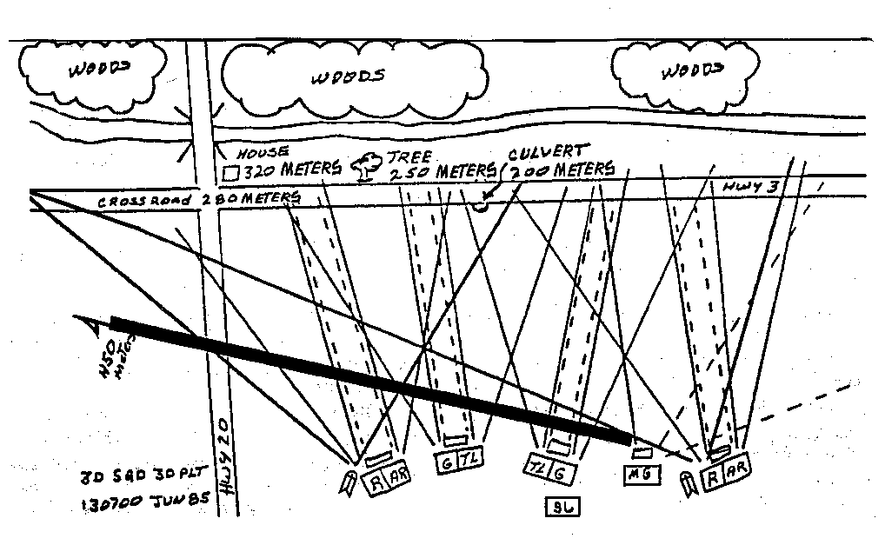
Figure 5-1. Infantry squad sector sketch.

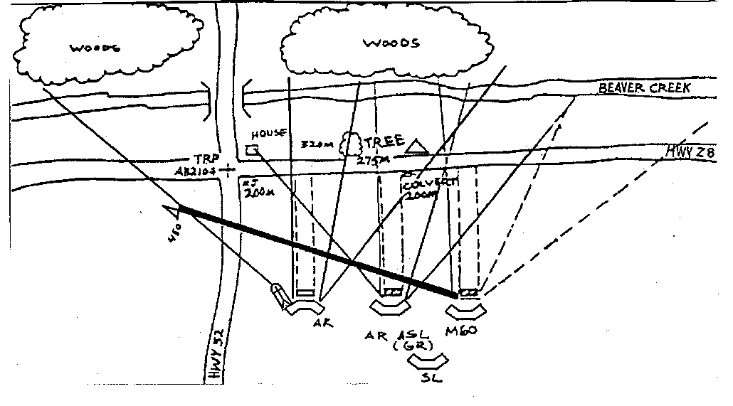
Figure 5-2. Mechanized infantry squad sector sketch.

Evaluation Preparation
Setup: Provide all equipment, material, and personnel given in the task conditions statement.
Brief Soldier: Tell the soldier that you will brief him on the sectors of fire for each individual weapon and attached crew-served weapons, any OPs, leader's position, and obstacles, and give him the crew-served weapons' range cards. Tell him that, using this information, he will prepare the element's defensive sector sketch.
Evaluation Guide
Performance Measures | Results
- The defensive sector sketch contains--  - Entire element’s sector. | P F

  - Each individual position.
  - Each crew-served weapon position.
  - Final protective lines.
  - Deadspace.
  - Leader’s position.

references
Required | Related
None | FM 7-7  FM 7-7J  FM 7-8

PREPARE A PLATOON SECTOR SKETCH

071-326-5770

CONDITIONS
Given a defensive sector, mortar final protective fire (FPF) assigned to the platoon-size element, paper, a map, and pencils. Provide positions for crew-served weapons and medium antitank weapons.

STANDARDS
The sector sketch is drawn as closely as possible to scale showing--
- The platoon sector.
- Squad positions (as applicable).
- Dragon and machine gun positions, with primary sectors of fire for each.
- Machine gun final protective lines (FPLs) or principal direction of fire (PDF).
- Observation posts (OPs).
- Target reference points (TRPs) (if applicable).
- Mines and other obstacles.
- Indirect-fire target locations.
- Indirect-fire FPF location.
- The location of the platoon command post (CP) and the OP.
- The unit designation (no higher than company level) and the date-time group.
NOTE: The parts of the sector sketch described above are the basic ones needed to make the sketch meaningful.
The unit SOP or the commander may require more detail.

TRAINING AND EVALUATION

Training Information Outline
- The platoon sector sketch assists the company or perimeter commander in preparing a company or perimeter fire plan. It also assists the platoon leader in shifting fires within the platoon sector without moving around to determine which weapon can fire into a certain area. If part of the platoon's area is threatened, the platoon leader can consult the sector sketch and quickly determine which weapons can cover the threatened area, and from which positions. The platoon leader can then direct (by radio, voice, or SOP signals) that their fires be shifted to the threatened area, or he can instruct them to move to alternate or supplementary positions.
- The sector sketch is made as follows:
  - Machine guns are assigned primary and secondary sectors of fire. Within the primary sector, the gunner is assigned a FPL or PDF, as appropriate.
  - Each MAW that is to cover the primary sector of fire is normally assigned a primary position and one or more alternate firing positions. Only primary positions with primary sectors of fire are shown on the sketch. If a supplementary position is assigned, it should be added to the sketch at the time it is assigned.
NOTE: Secondary sectors of fire from the primary position may be included if so ordered by the unit commander.
  - TRPs are labeled IAW unit SOP. They are plotted on an overlay to help identify target locations and to aid the control of direct and indirect fires. They should be plotted using man-made objects or terrain features within the platoon area. Indirect fires must be coordinated with the forward observer.
  - An FPF assigned to a platoon or element should be positioned across the most dangerous avenue of approach. The company or perimeter commander has final control of FPF placement, but he may ask for a recommendation from the platoon leader.
  - Any obstacle in the platoon area (stream, defile, dense woods, buildings) should be noted on the overlay. Man-made obstacles, such as minefields and defensive wire, are noted with the appropriate military symbol.
- The sample sector sketch fire plan in Figure 5-3 incorporates all the above listed points as taken from the squad sector sketches (Figure 5-2, page 5-3).

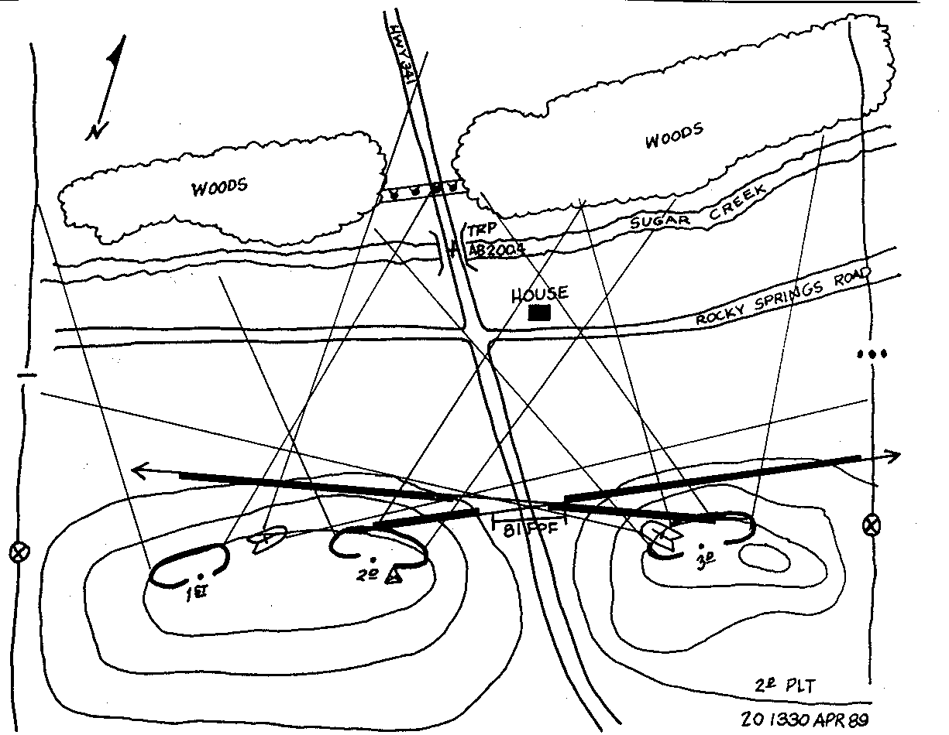
Figure 5-3. Sample light infantry platoon sector sketch.

Evaluation Preparation
Setup: At the test site, provide all materials and equipment given in the task conditions statement. Provide positions for all crew-served weapons assigned to the platoon-size element.
Brief Soldier: Tell the element leader he will prepare a sector sketch to include an overlay. The sketch will include sectors of fire of all weapons available to his element, plus any other information that will help him prepare his sector sketch.
Evaluation Guide
Performance Measures | Results
- Show the entire element’s sector in the sector sketch. | P F
- Show the primary sectors of fire for the machine guns. | P F
- Show each Dragon’s primary sector of fire. | P F
- Show the assigned Dragon supplementary positions. | P F
- Label the target reference point(s). | P F
- Plot the target reference point(s) using identifiable terrain features. | P F
- Show the final protective fires. | P F
- Show constructed or emplaced obstacles that are in the element’s area. | P F
- Show observation and command posts. | P F
- Show the unit’s designation and date-time group. | P F

REFERENCES
Required | Related
None | FM 7-7  FM 7-8  FM 101-5-1

SUPERVISE THE ESTABLISHMENT AND OPERATION OF A DISMOUNT POINT

191-377-4201

CONDITIONS
Given individual and crew-served weapons, ammunition, flashlight with filtered lens, communications equipment, night-vision devices, and access to unit SOP and Straggler Control Plan.

STANDARDS
- Select a location for the dismount point that allows maximum security for the command post.
- Perform all the necessary steps to establish and maintain communications and security.
- Ensure that all necessary steps are taken to control military traffic and the movement of refugees, local civilians, and stragglers.

TRAINING AND EVALUATION

Evaluation Preparation
Setup: You may train this task either in the classroom or in a walk-through mode. Reinforce both methods with hands-on training to perform the task to standard. To evaluate the task, schedule a field training exercise requiring soldiers to establish and supervise a dismount point. The exercise should have a CP and vehicles to enter the area.
Evaluation Guide
Performance Measures | Results
- Select location for dismount point based on the following:  - Dismount point should be located within or close to the outside perimeter.  - It should be easily accessible from the road.  - It should be easy for drivers to find.  - It should afford cover and concealment.  - Parking area should be level with a grassy or paved surface.  - Parking area must be within walking distance of the CP but not so close that direct fire will endanger the CP. | P F
  - If possible, select a site where the terrain can be used as a buffer between the parking area and CP.
- Establish security.  - Direct placement of crew-served weapons.  - Ensure that weapon is covered and concealed.  - If natural cover and concealment are not available, have the weapon camouflaged. | P F
- Establish communications IAW unit SOP. | P F
- Assign team members to the following positions:  - Team leader will provide leadership, maintain communications, and provide security for the dismount point operation.  - One MP will control movement at the dismount point.  - One MP will provide additional security and relieve the MP operating the dismount point. | P F
- Supervise the operation of the dismount.  - Provide leadership and advice as needed. | P F
  - Ensure team members perform their duties IAW Task 191-376-4108.
  - Have refugees and local civilians directed away from the dismount point area.
  - Ensure stragglers are processed IAW Straggler Control Plan.

REFERENCES
Required | Related
None | FM 19-4

SUPERVISE PROCESSING OF CAPTIVES FOR INTERNMENT

191-379-4413

CONDITIONS
Given orders, captives to be processed for internment, access to AR 37-36, AR 190-8, and FM 19-4, and completed--
- DA Forms 1132-R (Prisoner's Personal Property List-Personal Deposit Fund).
- DA Form 2662-R (United States Army EPW Identity Card).
- DA Forms 2663-R (Fingerprint Card).
- DA Forms 2664-R (Weight Register, Prisoner of War).
- DA Forms 2666-R (Prisoner of War Notification of Address).
- DA Forms 4237-R (Detainee Personnel Record).
- DD Forms 629 (Receipt for Prisoner or Detained Person).

STANDARDS
- Ensure that each captive is processed IAW the procedure listed in the camp processing plan.
- Ensure that each form is complete and accurate.

TRAINING AND EVALUATION

Evaluation Preparation
Setup: Provide a copy of the camp processing plan and copies of prepared forms listed in the conditions statement. The forms should have omissions and errors. Also, provide preprinted EPW/CI identification bands.
Brief Soldier: Explain to the soldier that all discrepancies must be identified and corrected.
Evaluation Guide
Performance Measures | Results
- Make sure all internees are searched. | P F
- Ensure that internees are allowed showers, shaves, and haircuts for personal hygiene. | P F
- Check that the internees receive a medical evaluation from medical personnel, if necessary. | P F
- Check that all internees are issued personal comfort items and clothing marked either “PW”, “CI”, or “RP”. | P F
- Make sure all internees are assigned an ISN. | P F
- See that all internees are issued a correctly prepared laminated identification band with an ISN. | P F
- Ensure the information on the identification board includes the internee’s full name and internment serial number. | P F
- Check that applicable forms are correctly prepared for internees who are either repatriated or transferred to HN or allied forces for internment. | P F
- See that the height and weight of all internees is recorded. | P F
- Check that all internees are fingerprinted. | P F
- Ensure that all internees are issued a correctly prepared identification card. | P F
- Check that a photograph of each internee is attached to his DA form 4237-R. | P F
- When the personal effects of internees are returned, stored, impounded, or confiscated, ensure-- | P F
  - The items are recorded on DA Forms 4237-R or 1132-R.
  - Internees are given one copy of each form as a receipt.
- Ensure that an accountability roster is maintained for all internees processed. | P F
- When transferring accountability of internees, make sure that the receiving person and/or unit sign a DD Form 629. | P F
- Check that all internees have a completed DA Form 2666-R. | P F
- Make sure that all applicable forms are complete and accurate. | P F

REFERENCES
Required | Related
AR 37-36  AR 190-8  FM 19-4 | None

BRIEF PRISONER ESCORTS

191-383-3367

CONDITIONS
Given prisoner escorts and access to AR 190-47 and FM 19-60.

STANDARDS
You must brief the escort guards on all aspects of the task required to accomplish the mission.

TRAINING AND EVALUATION
Evaluation Guide
Performance Measures | Results
- Make sure there are enough guards for the escort per SOP. | P F
- Make sure the senior guard is a NCO or officer or at least the same rank as the prisoner. | P F
- Brief the escort guards. Include, as a minimum-- | P F
  - Type of transportation to be used (see Tasks 191-381-1300, 191-381-1301, and 191-381-1540).
  - Telephone numbers for the facility, military police, and civilian police along the route.
  - When hand irons or other physical restraints must be used.
  - Actions to take if there is a delay en- route.
  - Actions to take if prisoner attempts an escape.
  - Type of weapons to use, if authorized, and the proper “use of force” (see Task 191-381-1292).
  - Instructions to--
- Search prisoners including when, where and how.
- Receipt for prisoners on DD Form 629 before leaving the facility.
- Keep prisoners segregated from other persons.
- Notify the I/R supervisor upon arrival at destination and again at the beginning of the return trip.
- Keep the prisoners from obtaining contraband.
- Obtain a receipt on DD Form 629 for the prisoners when they are released to authorized personnel outside your correctional/ confinement facility.

REFERENCES
Required | Related
AR 190-47  FM 19-60 | None

DIRECT ACCOUNTABILITY PROCEDURES FOR PRISONERS

191-383-3370

CONDITIONS
Given a prisoner roster, local SOP, and a prepared DA Form 3997 (Military Police Desk Blotter).

STANDARDS
You must ensure that all prisoners are accounted for at all times.

TRAINING AND EVALUATION
Evaluation Guide
Performance Measures | Results
- Ensure that I/R personnel have an up-to-date prisoner roster. | P F
- Direct I/R personnel to conduct--  - Roll calls--  - At morning formations.  - At evening formations.  - At other times as directed by the facility commander. | P F
  - Head counts--
- At noonday formations.
- Immediately upon return of all prisoners from a work detail.
- At other times as directed by the facility commander.

  - Bed checks--
- Between taps and midnight.
- Between midnight and reveille.
- At other times as directed by the facility commander.
NOTE: The installation officer of the day, the facility staff duty officer, or the military police duty officer will conduct a separate bed check between midnight and reveille and at other times as directed by the installation or facility commander.
- Ensure that roll calls, head counts, and bed checks are conducted (see Task 191-382-2290). | P F
- Report all discrepancies to the supervisor and follow procedures IAW local SOP for notifying the proper authorities such as the-- | P F
- Facility commander.
- Provost marshal.
- MP desk sergeant.
- City, county, and/or state police.
- County sheriff.
- FBI.
- Escapees’ hometown police.
- Direct guards to conduct head counts and roll call if there is a fire, disorder, escape, or testing of the facility emergency plans. | P F
- Ensure that all roll calls, head counts, and bed checks are entered in the facility. | P F

REFERENCES
Required | Related
None | AR-190-47  FM 19-60

SUPERVISE ADMINISTRATIVE AND DISCIPLINARY MEASURES IN A CORRECTIONAL/CONFINEMENT FACILITY

191-383-3396

CONDITIONS
Given--
- Prisoners who are in administrative/disciplinary segregation.
- A segregation area.
- Prepared DD Forms 503 (Medical Examiner's Report), 508 (Report of or Recommendation for Disciplinary Action), and 509 (Inspection Record of Prisoners in Segregation).
- Access to AR 190-47.

STANDARDS
You must ensure--
- Prisoners are correctly segregated based on their category.
- All required forms are complete and accurate.
- All guidelines for prisoners in administrative/disciplinary segregation are adhered to.

TRAINING AND EVALUATION

Evaluation Preparation
Setup: Create various scenarios involving administrative and disciplinary segregation. Have other soldiers act as prisoners and guards. Provide all equipment and materials as listed in the conditions statement.
Brief Soldier: Explain to the role-players the actions they are to take.
Evaluation Guide
Performance Measures | Results
- Ensure prisoners in administrative segregation are separated by the following categories:  - Homosexuals (either recognized homosexuals or those who exhibit homosexual behavior).  - Informers.  - Escape-risk prisoners. | P F
  - Prisoners pending investigation for violation of facility rules and regulations.
  - Medical observation.
  - Prisoners with psychological disorders who do not adjust to living with other prisoners.
  - Protective custody.
  - New confinees (for observation by custodial personnel and until examined by a medical officer).
  - Suicide risks.
- Ensure that prisoners placed in administrative segregation are advised as to the purpose of the action. | P F
- Ensure prisoners have adequate sleeping accommodations with sufficient bedding, are issued the same clothing as other prisoners, and have an adequate supply of health and comfort items. | P F
- Ensure cell furnishings, beds, and/or bedding is removed when necessary.  - Request cell furnishings, beds, or bedding be removed when the prisoner shows suicidal or destructive tendencies.  - Provide a sleeping board, elevated from the floor, and constructed of wood and heavy material.  - Inspect DD Form 509 ensuring that the above actions (steps 4a and 4b) are annotated in the "remarks" section. | P F
- Ensure custodial personnel observe prisoners and record their observations on DD Form509. Make sure-- | P F
  - Prisoners in disciplinary segregation are checked at irregular intervals with no more than 30 minutes expiring between checks.
  - Prisoners who are classified as a suicide risk are checked at irregular intervals with no more than 15 minutes expiring between checks.
  - Other prisoners who are identified by the facility commander or medical officer, nurse clinician, or warrant officer physician assistant are checked as required.
- Schedule a minimum of 30 minutes of physical exercise each day for prisoners in administrative and disciplinary segregation. | P F
- Plan and coordinate prisoner work details within the segregated area. | P F
NOTE: Some prisoners in administrative segregation (based on the purpose of the segregation) may work outside the segregated area.
- Coordinate visiting procedures for prisoners in administrative and disciplinary segregation. | P F
- Verify on DD Form 509, Part II, that prisoners in close confinement are visited by the following personnel at least once a day: | P F
- Warrant officer physician's assistant, nurse clinician, or medical officer.
- Chaplain.
- Counselor.
NOTE: There is no area on the front of the DD Form 509 for the counselor and the chaplain to sign, they will sign, date, and place the time of their arrival on the reverse side of the form. If this is not being done, inform your supervisor.
- Verify on DD Form 509, Part II, that the facility commander or his representative and the duty officer visit prisoners in close confinement twice a day. If this is not being done, notify your supervisor. | P F
- Supervise disciplinary segregation. | P F
  - Check DD Form 508 to make sure it is complete and that it has been approved by either the Installation Commander, the Deputy Installation Commander, or the Chief of Staff.
  - Ensure that a medical certification is obtained on DD Form 503.
  - Check DD Form 509 to be sure it is being maintained correctly and that the instructions on it are followed.
- Check that prisoners who display destructive or suicidal tendencies, or who consistently refuse to comply with orders, are reported to the facility commander with a recommendation that the prisoners be classified intractable. | P F
- When prisoners are classified intractable, check that--  - They are advised of the reason for the intractable designation.  - They remain confined within the cell. | P F
NOTE: Only the facility commander or a designated representative can approve a prisoner who is classified intractable to leave the cell.
  - The facility commander reviews the prisoner's classification every 72 hours.
  - Each prisoner's correctional treatment file contains written documentation of the intractable classification.
  - Intractable prisoners are visited once each day by a warrant officer physician assistant, nurse clinician or medical officer, a chaplain, and a counselor.
  - The prisoner is visited twice each day by the installation or facility duty officer and by the facility commander or a designated representative.

REFERENCES
Required | Related
AR 190-47 | None

INSPECT PHYSICAL SECURITY OF A CORRECTIONAL/CONFINEMENT FACILITY

191-384-4375

CONDITIONS
Given--
- An equipped and functional correctional/confinement facility.
- The facility SOP.
- A requirement to conduct a physical security inspection.
- Either a blank, locally produced inspection report form, a blank DA Form 2806-1-R (Physical Security Inspection Report), or a blank DA Form 2806-R (Physical Security Survey Report).
Performance Measure 3 must be performed during the hours of darkness.

STANDARDS
You must perform all the necessary steps to--
- Ensure all physical security requirements are in place and enforced.
- Prepare a physical security inspection report on all deficiencies and forward the report to the appropriate authority.

TRAINING AND EVALUATION

Training Information Outline
- Inspect the perimeter fence and gates. Check that--
  - The double exterior fencing is constructed of at least #9 gauge wire and is a minimum of 14 feet high with overhangs.
  - There is a 1 foot top guard attached to the fence.
  - Both the fence and top guard are intact.
  - The fence is taut and securely fastened to rigid metal or reinforced concrete posts set in cement.
NOTE: Make sure that top rails are not used on fences because they could be used in escape attempts and by intruders.
  - Openings in the fence do not exceed 2 inches.
  - The bottom of the fence is within 2 inches of hard ground or paving. If the fence is on soft ground, the fence must reach below the surface deep enough to compensate for shifting soil or sand.
  - The gates and gate hinges are securely attached to the gate frame.
  - There are no objects on or near the perimeter fence that will prevent an unobstructed view or that will help the prisoner climb over the fence.
  - Buildings less than two stories which form part of the perimeter have top guards installed along the edge of the roof to prevent escapes and intrusions.
  - There is no vegetation on or near the perimeter fence exceeding 8 inches in height. (Vegetation exceeding 8 inches will reduce the effectiveness of the fence by impeding observation or by providing concealment.)
  - Utility openings of 10 or more inches that pass through perimeter barriers must have security equivalent to that of the barriers.
  - Any building opening that could be used as an avenue of escape is secured.
- Inspect perimeter guard towers. Ensure--
  - The guard in each perimeter tower has an uninterrupted view for a minimum of 80 yards in any direction along the perimeter fence line.
  - The combined views from all towers allow for observation of the entire exercise yard.
  - Primary and backup communications systems allow the tower guards to send and receive clear messages to and from other key areas of the confinement facility.
- Inspect the outside security lighting. Check that--
  - Exterior lighting is operated during hours of darkness and limited visibility and that the entire perimeter is lighted with overlapping cones of light.
  - All exterior lights are covered with wire mesh screen or other material to keep them from being broken.
  - The lights are positioned to prevent glare which may blind the guards.
  - The lights are positioned so that they do not silhouette or highlight the guards.
  - All entrances, exits, and gates are adequately illuminated to allow for the recognition of persons, the examination of individual identification, and the searching of vehicles and prisoners.
  - All areas within the armed guards’ fields of fire are lighted.
- Inspect parking areas. Check that--
  - All parking areas are well lighted and inaccessible to prisoners.
  - All vehicle parking is restricted to designated parking areas and limited to personnel on duty at the confinement facility and to authorized visitors.
  - A notice is posted to remind personnel to lock vehicles.
- Make sure entry and exit procedures are enforced (see Tasks 191-381-1304, 191-381-1305, and 191-381-1306).
- Check that the facility lock and key control procedures are enforced. Make sure--
  - Keys are signed out to authorized personnel, as required, on a key control register.
  - The key control register (when not in use) is kept in a locked container to which access is controlled.
  - A lockable container, such as a safe or filing cabinet, or a key depository made of at least 26-gauge steel, equipped with a tumbler-type locking device, and permanently attached to a wall, is used to secure keys.
  - The key depository is located in a room where it is kept under surveillance around-the-clock or in a room that can be locked during nonduty hours.
  - A key and/or lock inventory list is maintained which depicts a list of all keys and locks and their serial numbers, the location of the locks, and the number of keys maintained for each lock. Check that the list is secured in the key depository.
  - The keys are not labeled or inscribed with the location of the lock.
  - Locks and their keys are inventoried by serial numbers at least semiannually.
  - Locks and/or their combinations are changed when loss or compromise is suspected.
  - When a key to a padlock is determined missing, the padlock is replaced or recored immediately.
  - Lock combinations are changed every 12 months or when personnel having access depart, whichever occurs first.
  - Master keyed or keyed-alike lock sets are not used.
- Check prisoner movement procedures. Make sure prisoner movement is controlled by escort procedures and, if used, the procedures implemented for an intrafacility pass system (see Task 191-381-1256).
- Check that visitor's lockers (or comparable security containers) are used.
- Check that contraband control procedures are in place to include--
  - Daily inspections of prisoners and cellblock areas.
  - Search procedures to include--
    - Shakedowns. Shakedowns of prisoners and their work and living areas will be performed at least once each month.
    - Search of prisoners. Make sure--
      - All prisoners are frisk searched before and strip searched after each visitation period.
      - All newly assigned prisoners are strip searched and all their possessions are searched, inventoried, and processed.
      - All prisoners are strip searched when returned from outside escort such as for medical and dental appointments.
      - All prisoners are strip searched before release or transfer.
      - All prisoners are frisk and/or strip searched, as applicable, when they return from a work detail.
      - Prisoner cooks and KPs are frisk and/or strip searched, as applicable, whenever they leave the dining facility.
      - All prisoners are frisk searched after each meal (see Task 191-381-1316).
  - Inspect the security of supplies. Check that--
    - Medical supplies (those, which would be dangerous in the possession of prisoners) and all medications are secured in locked containers.
    - Pesticides, cleaning supplies, paints, and toxic items are stored in a safe place and secured in locked containers.
  - Inventory control. Check that the following are accounted for on an inventory:
    - Medication. (Medication should be inventoried daily.)
    - Silverware. (Silverware must be inventoried before and after each meal. See Task 191-381-1315.)
    - Knives, cleavers, and similar kitchen equipment. (The kitchen supervisor must be able to account for all items at all times. Items should be inventoried at least once during each shift.)
    - Work tools. (Work tools must be accounted for daily and inventoried at least twice each month.)
    - Recreation and welfare supplies and equipment. (These must be inventoried periodically IAW facility SOP.)
    - Health and comfort items in bulk storage. (These must be inventoried once each month.)
- Check that all emergency and riot control gear is secured in an area that is inaccessible to prisoners.
CAUTION
The storage area for emergency and riot control gear must be located in an area that cannot be controlled by prisoners during a major disorder.
- Check the emergency generator. Ensure it is--
  - Operational.
  - Tested weekly and that the results of the test are recorded in the confinement facility desk blotter.
  - Located in an area inaccessible to prisoners.
- Inspect work orders on security devices and upgrades and make sure all work orders are current.
- Prepare a physical security inspection report and forward it to the appropriate authority, as directed.
NOTE: You must reinspect within a six-month period if major deficiencies were indicated during the initial inspection.

Evaluation Preparation
Setup: You may evaluate this task with a written test.
Evaluation Guide
Performance Measures | Results
- Inspect perimeter fence and gates. | P F
- Inspect perimeter guard towers. | P F
- Inspect the outside security lighting. |  |  | P F
- Inspect all parking areas. |  |  | P F
- Check entry and exit procedures. |  |  | P F
- Ensure the facility lock and key control procedures are enforced. |  |  | P F
- Check that prisoner movement control procedures are enforced. |  |  | P F
- Check that visitor’s lockers (or comparable security containers) are used. |  | P F
- Check that contraband control procedures are in place and enforced. |  | P F
- Check that all emergency and riot control gear is secured in an area that is inaccessible to prisoners. |  | P F
- Check the emergency generator. |  | P F
- Inspect work orders on security devices/upgrades. |  | P F
- Prepare physical security inspection report and forward it to the appropriate authority as directed. |  | P F

REFERENCES
Required | Related
None | AR 190-11  AR 190-47  FM 19-30  FM 19-60

DIRECT SECURITY PROCEDURES WITHIN A DINING FACILITY

191-384-4403

CONDITIONS
Given a confinement/I/R dining facility, the facility SOP, and the required I/R personnel. This task may not be performed in MOPP 4 conditions.

STANDARDS
Perform all the necessary steps to ensure--
- Security procedures are enforced within the dining facility.
- Security procedures pertaining to internee meals within close confinement are enforced.
- Special and/or dietary restrictions for internees in close confinement are adhered to.

TRAINING AND EVALUATION

Evaluation Preparation
Setup: This task may be evaluated with a written test.

Evaluation Guide
Performance Measures | Results
- Brief the supervisor assigned to the kitchen area. Instruct him to--  - Inspect food deliveries for contraband.  - Control spices, flavorings, sugar, yeast, vegetables, and fresh or dried fruit to keep the internees from using them to make alcoholic beverages. | P F
  - Control meat cleavers, knives, ice picks, and other items that internees could use as weapons.
  - Make periodic checks of garbage and trash to detect contraband.
  - Make periodic checks of the workers to ensure all control measures are enforced.
- Brief the supervisor assigned to the dining area during internee meals to be sure he is familiar with—
  - The internee meal schedule.
  - The seating plan.
  - The names of the I/R personnel detailed to assist.
- Security control procedures as outlined in SOP. | P F
- Make periodic checks of the supervising I/R personnel and the assistants who are providing custody and control of the internees during internee meals. | P F
- Direct meals of internees in close confinement.  - Check that meals are IAW special or dietary restrictions indicated on the DD Form 509, if applicable.  - Instruct cellblock guards to collect all silverware, trays, and containers after the internee completes the meal.  - Advise guards on the proper disposal or accountability of the items. | P F

REFERENCES
Required | Related
None | AR 190-47

PREPARE PRISONER STRENGTH RECORDS

191-383-3379

CONDITIONS
Given--
- A blank DD Form 506 (Daily Strength Record of Prisoners).
- The completed DD Form 506 from the previous day.
- A blank DD Form 515 (Roster of Prisoners).
- A partially prepared DD Form 515.
- A prepared DA Form 3997 (Military Police Desk Blotter).

STANDARDS
You must--
- Prepare DD Form 506 without error.
- Make all required entries to DD Form 515 without error.

TRAINING AND EVALUATION
Evaluation Guide
Performance Measures | Results
- Review the completed DD Form 506 for the period 0001 through 2400 hours for the previous day. Using the information on the form, prepare a DD Form 506 in triplicate for the current day (Figures 5-4a and 5-4b, page 5-24). | P F
- If there is an incorrect entry, enter a statement of | P F
correction in Section I, Part C, "Changes/ Remarks" Section. For example, "DD Form 506 dated ___________ as reads _________; should read _____________. Correction has been incorporated in the present strength report and noted on file copy as a pen and ink addition to DD Form 506 prepared on the date of error.”
- Complete Section I, Part A, "Gains." Using the information from the DA Form 3997 from the previous day, list all newly confined prisoners. Include prisoners who were transferred in from another facility. | P F
- Complete Section I, Part B, "Losses." Using the information from the DA Form 3997 from the previous day, list all prisoners who were released, transferred, escaped, or who died during the period 0001 through 2400. | P F

Figure 5-4a. Example of front of DD Form 506.
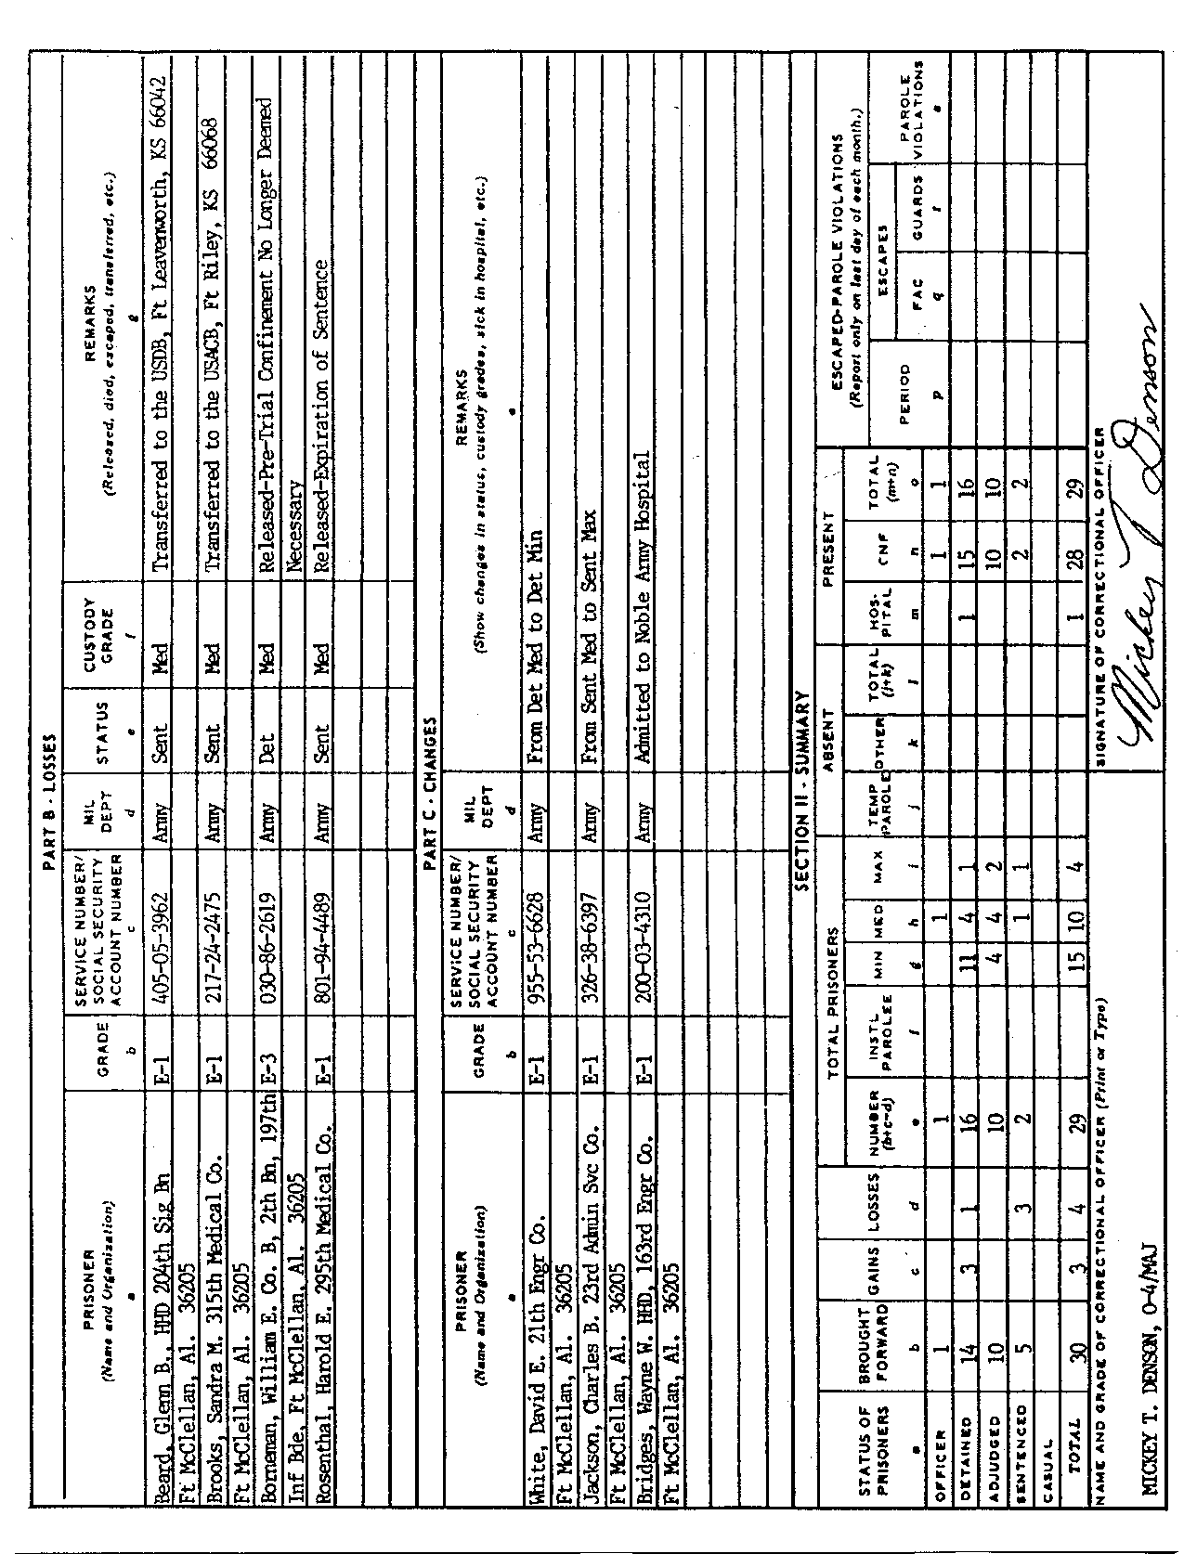
Figure 5-4b. Example of back of DD Form 506.

- Complete Section I, Part C, "Changes." Include--  - Changes in prisoner status.  - Changes in custody grade.  - Prisoners who are in the hospital or who were returned from the hospital.  - Prisoners who are on temporary home parole or who were returned from temporary home parole. | P F
- Complete Section II, "Summary."  - Using the previous day's report (DD Form 506), transfer the figures from Column "o" to Column "b" of the new form.  - Using the new form, enter the total gains from Section I, Part A, "Gains," in Column "c". Enter in Column "d" the total "Losses" from Section I, Part B. | P F
- Transfer information from Section I, Part C, "Changes," of the current day's new form to Section II, "Summary," Column "c", "Gains" and Column "d", "Losses."
- Add the figures in Columns "b" and "c". Subtract column "d" from the totals. Enter the results in column "e".
- Fill in columns "f" through "o". Add columns "j" and "k" to find the numbers to enter in column "1". Add columns "m" and "n" to find the numbers to enter in column "o".
- Check your answers. Column "1", plus Column "o", must equal Column "e".
- If the form is completed for the last day of the month, enter the required information in the "Escaped-Parole Violations" columns "p" through "s". | P F
- Type a signature block for the correctional officer to sign. | P F
- Prepare DD Form 515, Roster of Prisoners (Figure 5-5a and 5-5b, page 5-28).  - At 2400 hours on the last day of each month, place in alphabetical order the names of all prisoners who are still in confinement. Then prepare a new DD Form 515 dated with the month and year. | P F
  - During the month, as new confinees arrive at the confinement facility, use the information from the prepared DA Form 3997, Military Police Desk Blotter, and enter the date of confinement on the next blank line on DD Form 515 in the order in which the prisoners are confined.
  - On the line below the date, enter the confinee's name.

  - Complete the "Sentence" column immediately after each prisoner's sentence becomes available.
  - Put the computed minimum release date of each prisoner in the "Minimum Release Date" column.
  - Enter the date and authority for each prisoner's release and transfer, or the date of escape or death, in the"Remarks" column. You will also enter orders modifying a sentence or orders for forfeiture or restoration of good conduct time in this column.
  - Upon transfer or release of a prisoner, line through the prisoner's name and make sure the facility commander initials the entry.

REFERENCES
Required | Related
None | AR 190-47  FM 19-60

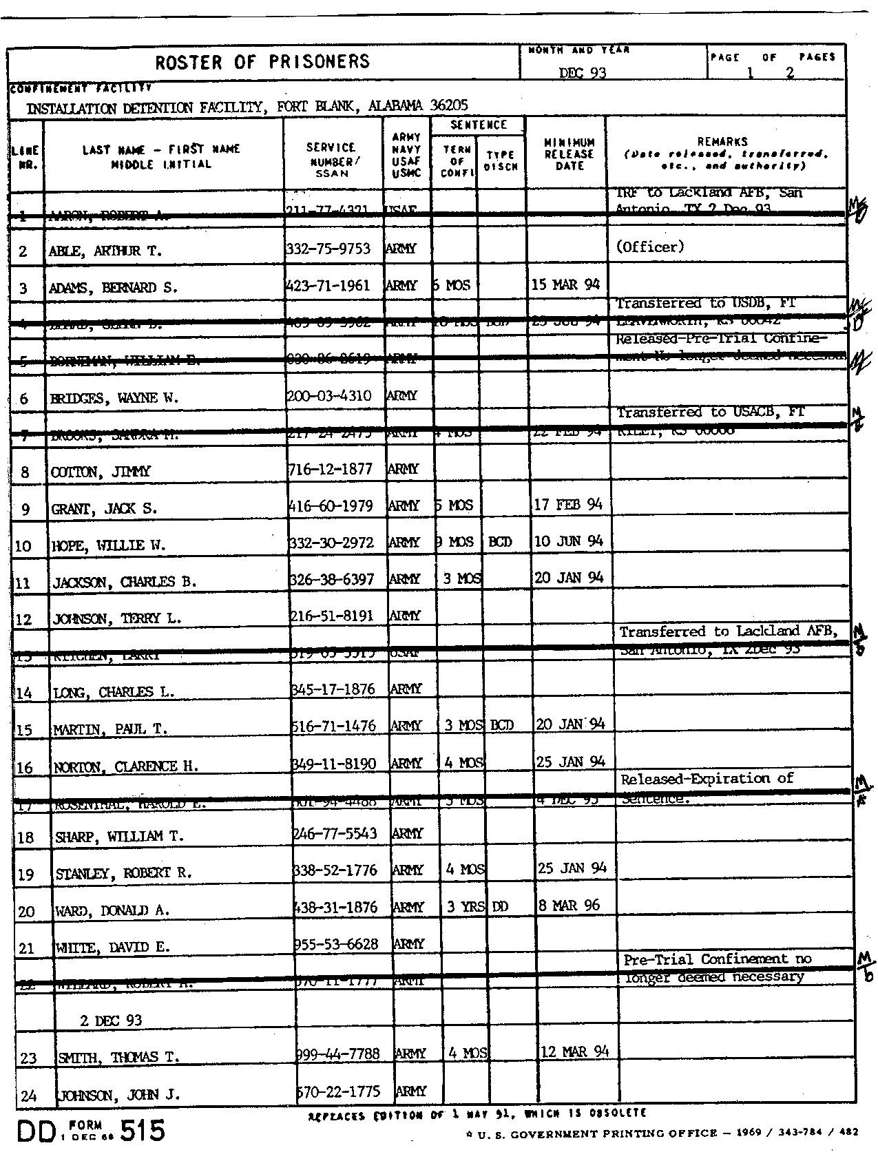
Figure 5-5a. Example of front of DD Form 515.
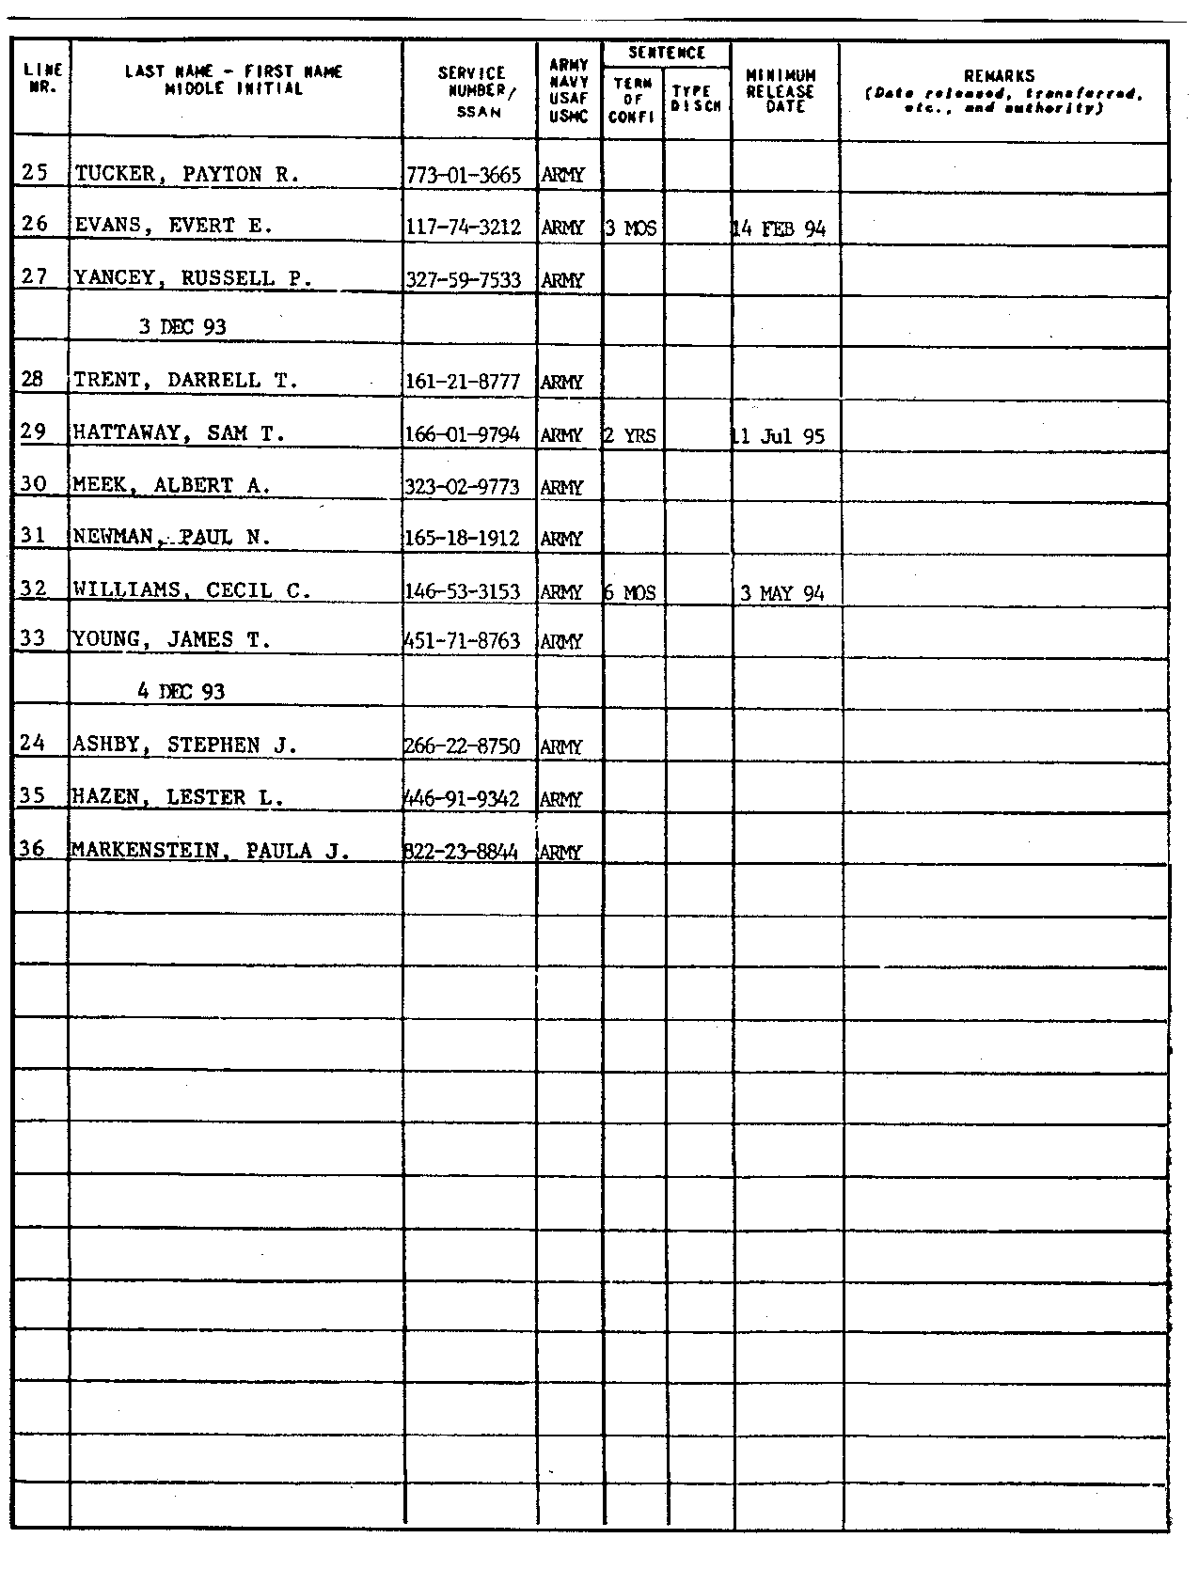
Figure 5-5b. Example of back of DD Form 515.

SUPERVISE PRISONER PROCESSING

191-383-3398

CONDITIONS
Given a requirement to inprocess a prisoner and--
- Prepared DA Forms 3078 (Personal Clothing Request), 4137 (Evidence/Property Custody Document), 1132-R (Prisoner's Personal Property List-Personal Deposit Fund), 3955 (Change of Address and Directory Card), and 3997 (Military Police Desk Blotter).
- Prepared DD Forms 497 (Confinement Order), 498 (Prisoner's Personal History Record), 499 (Prisoner's Mail and Correspondence Record), 503 (Medical Examiner's Report).
- Prepared FD Form 249 (FBI Criminal Fingerprint/Arrest Card).
- Facility rule book.
- Access to the facility SOP and AR 190-47.
- Show facilities.
- Health and comfort items.
- An area/cell located away from the general prison population.

STANDARDS
You must make sure all inprocessing procedures and requirements are correctly administered, completed, recorded, or corrected IAW AR 190-47 and the facility SOP.

TRAINING AND EVALUATION
Evaluation Guide
Performance Measures | Results
- Review the following forms and ensure they are complete and accurate.  - DD Form 497.  - DA Form 3078.  - DD Form 498.  - DD Form 503.  - FD Form 249.  - DD Form 499.  - DA Form 4137.  - DA Form 1132-R.  - DA Form 3955. | P F
- Ensure prisoner is strip searched. | P F
- Ensure prisoner showers, and shaves, if necessary, and dresses in the authorized uniform. | P F
- Ensure all of the prisoner's clothing and personal property is searched, segregated, and inventoried correctly. | P F
- Ensure all contraband is disposed of IAW facility SOP. | P F
- Ensure each prisoner is issued bedding and health and comfort items IAW facility SOP. | P F

- Ensure prisoner's authorized personal property which he cannot keep in his cell is inventoried and secured and that the prisoner is given a copy of the receipt. | P F
- Ensure each prisoner is photographed. | P F
- Ensure each prisoner is fingerprinted. | P F
- Ensure each prisoner is briefed on the rights and privileges concerning mail. | P F
- Ensure a medical examination is scheduled to occur within 24 hours of prisoner's confinement. | P F
- Ensure all prisoners are issued a facility rule book and that each is briefed on the facility rules and regulations IAW AR 190-47 and the facility SOP. | P F
- Ensure all new prisoners are kept segregated from the general prison population during the inprocessing procedure. | P F
- Ensure the new confinement is recorded on the facility blotter. | P F

REFERENCES
Required | Related
AR 190-47 | FM 19-60

